

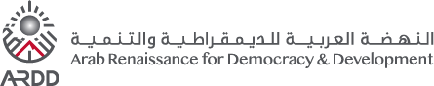

Good Practice in Disability-Inclusive Social Security
Briefing Note

https://www.developmentpathways.co.uk/
December 2024

Table of Contents
1 Introduction 1
2 Social Security: a Tool to Address Challenges Faced by Persons with Disabilities 3
3 Modern Comprehensive Social Security Systems 7
4 Making Social Security Disability-Inclusive 10
4.1 Good practice in the overall design of disability-inclusive social security systems 10
4.2 Good practice in the design of disability-specific and -relevant schemes 11
4.2.1 Recipient of the transfer 12
4.2.2 Work requirements 12
4.2.3 The use of means testing 13
4.2.4 The type of disability assessment mechanism used 14
4.2.5 Transfer values 14
5 Conclusion 17
Bibliography 18

Acronyms

CRPD | Convention on the Rights of Persons with Disabilities
DHS | Demographic and Health Survey
DoS | Department of Statistics
GDP | Gross Domestic Product
ICESCR | International Covenant on Economic, Social and Cultural Rights
ICF | International Classification of Functioning, Disability and Health
ILO | International Labour Organization
IMF | International Monetary Fund
JOD | Jordanian Dinar
JPFHS | Jordan Population and Family Health Survey
NAF | National Aid Fund
SSC | Social Security Corporation
UDHR | Universal Declaration of Human Rights
UNFPA | United Nations Population Fund
UNICEF | United Nations Children’s Fund
USD | United States Dollar
WG | Washington Group on Disability Statistics
WHO | World Health Organization

Introduction
Social security is an essential public service, crucial for ensuring income security, reducing poverty and protecting individuals and families from life risks and shocks such as unemployment, sickness, disability and old age. Social security systems comprise income transfers that governments offer to their citizens and legal residents. They are designed to: (1) guarantee a minimum income for all, usually through tax-financed schemes, thereby ensuring financial stability; and (2) support people to smooth their incomes over time through contributory schemes, thereby helping maintain a more stable standard of living. Social security is one component of broader social protection; the other component is social services (see Figure 1-1).
Figure 1-1: The definition of social protection as two essential public services
Social protection is defined as comprising two essential public services: social security (income support) and personal social services (personal care and support). This brief covers social security only.
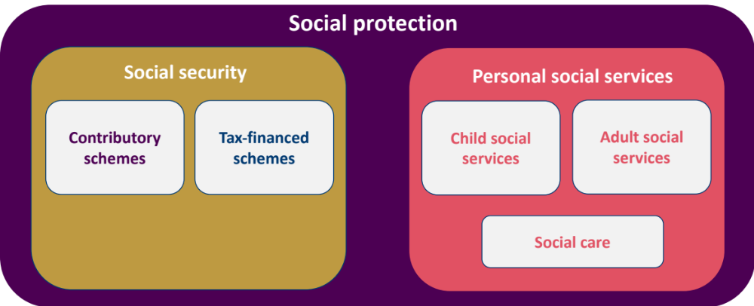
Source: Shamil (2024). The definition used by Shamil is derived from international standards of classification of public services.
Persons with disabilities often require access to support across a broad range of public services, as indicated by Figure 1-2. These might include early identification and intervention, health (including rehabilitation services and assistive devices), education and training, active labour market programmes, accessible housing, transport and more. However, they also include social protection - both access to social security and personal social services. It is crucial to acknowledge that the specific requirements of every person can be different.
Figure 1-2: Support required by persons with disabilities cuts across a range of public services
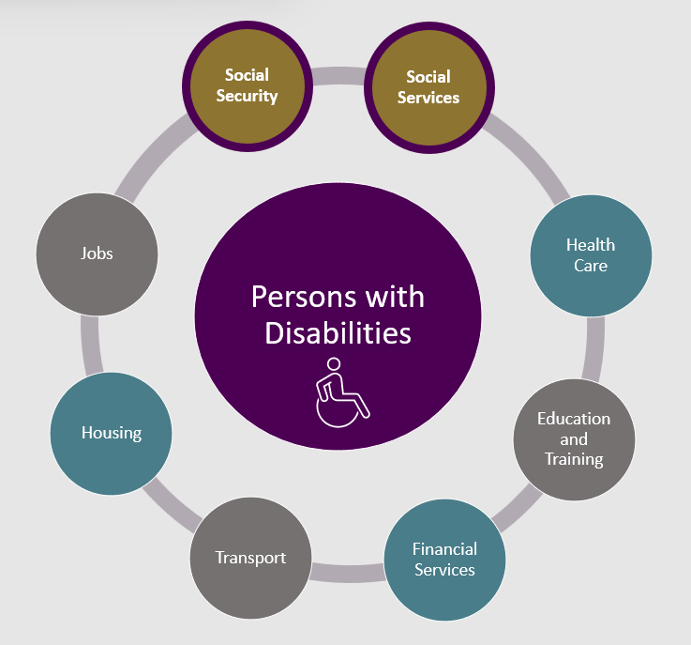
Source: Development Pathways.
Social security is a fundamental human right that should be accessible to everyone, whenever they require it, at any point in their life. For persons with disabilities, this right is reinforced by several international human and labour rights frameworks.
Making social security disability-inclusive means ensuring that persons with disabilities can access social security schemes on an equal basis to other members of society, as well as ensuring the availability of schemes specifically for persons with disabilities which address the challenges they face. Therefore, social security systems should ensure: (1) equitable access to income support for persons with disabilities; (2) provisions to cover additional costs associated with disability; (3) flexibility to meet the diverse needs of persons with disabilities and their families; (4) equal opportunities for persons with disabilities to enrol in social security programmes; and (5) an inclusive design that eliminates barriers, ensures that persons with disabilities are treated with dignity and prevents exclusion.
This briefing note explains the challenges persons with disabilities can face throughout their lives and the vital role social security can play in addressing them. It also explores international good practices in disability-inclusive social security systems, outlining what a comprehensive framework entails.

Social Security: a Tool to Address Challenges Faced by Persons with Disabilities
There is a strong rationale for investing in disability-inclusive social security in Jordan. According to the most recent Demographic and Health Survey, 14 per cent of the population has some level of disability, with 3.5 per cent experiencing moderate or severe disabilities. Disability prevalence increases with age (see Figure 2-1) and, while the highest rates of disability are found among those aged 80+ years, due to the structure of Jordan’s population (with a relatively large youth population) the largest number of persons with a disability of any degree falls within the 20-29 years age group. As Jordan's population ages, the number of people who are of retirement age (aged 55 years and over for women and 60 years and over for men) is projected to more than double, from around 620,000 in 2020 (six per cent of the population) to 2.15 million by 2050 (16.6 per cent). This demographic shift is expected to significantly increase disability prevalence.
Figure 2-1: Disability prevalence by age group in Jordan
Source: DoS and ICF (2024). Note: Disability prevalence is only reported for individuals aged five years and above.
Focusing solely on individual disability prevalence, however, risks overlooking the broader societal impact of disability which affects the individual concerned, as well as families and communities. 14.0 per cent of the population live in a household that includes a person with a moderate or severe disability, while 45.2 per cent live in a household with someone with any form of disability (some difficulty and more).
The relationship between disability and low standards of living is deeply interconnected, with each reinforcing the other (see Figure 2-2). Many persons with disabilities and their families live on low and insecure incomes. Indeed, the Arab Barometer's most recent public opinion survey (2024) found that 61 per cent of Jordan’s population report struggling to provide their families with food through to the end of the month. This indicates that a significant portion of the population, including persons with disabilities, would benefit from improved access to adequate social security.
Banks and Polack (2014) highlight that income-related factors—such as limited access to social security, affordable health care, quality education and inadequate living conditions—significantly increase the risk of acquiring a disability. On the other hand, living with a disability can further entrench income insecurity by limiting opportunities for persons with disabilities to fully participate in the social and economic life of their communities. Access to essential public services and support systems, such as health care, education and social security programmes, are critical for improving quality of life and economic participation of persons with disabilities and their families. Failure to invest in persons with disabilities through social security is a lost opportunity both for individuals to achieve their potential and for economic growth. It is crucial that persons with disabilities are ensured access to a wide range of public services, including social security, to break this cycle.
Figure 2-2: The disability and poverty cycle
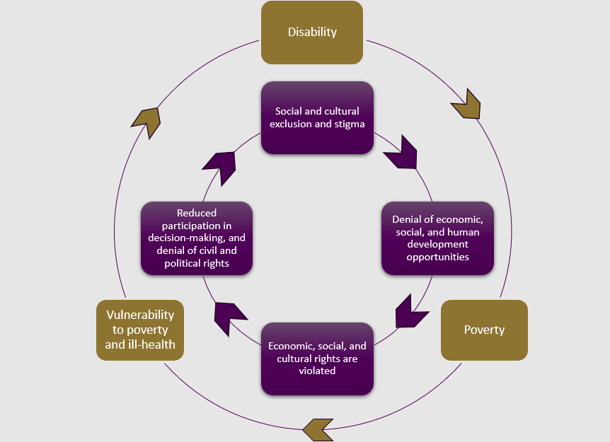
Source: Kidd et al. (2019), based on Figure 1 in Banks & Polack (2014).
When considering the standards of living of persons with disabilities, it is crucial to consider the additional costs that they experience resulting from their impairments. Costs vary depending on a person’s needs and the accessibility of their surroundings, and can include expenses for health care, assistive devices, education, transport, housing adaptations and personal care. Direct costs might include items like transport, assistive devices, diapers or medicine. Persons with disabilities may earn less due to barriers in education and employment, while family members may lose income by cutting back on work or education to provide care. These are indirect costs of disability, arising from lost opportunities for income generation.
The additional costs experienced by households with a person with a disability can be considerable. Globally, they have been found to vary between eight and 58 per cent of household spending. An initial analysis of the additional costs in Jordan indicates that they are 13.7 per cent of household income on average (as depicted in Figure 2-3). Therefore, a typical household with a person with a disability would need an additional JOD152 (about US$214) per month to maintain the same standard of living as a household without a person with a disability with the same income.
Figure 2-3: The additional costs of disability and their impacts on standards of living
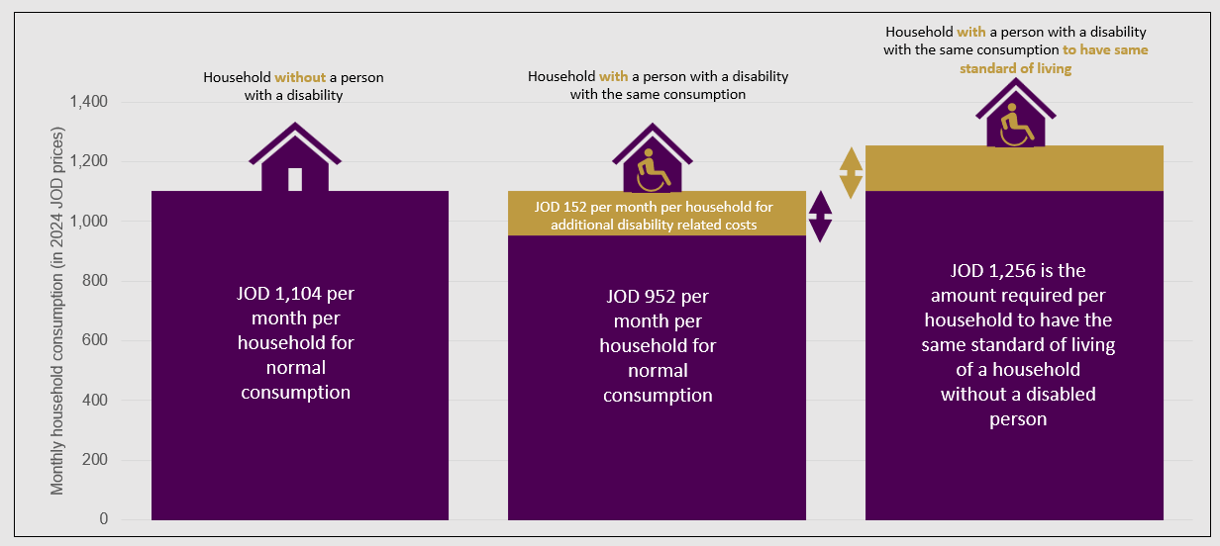
Source: Development Pathways.
As well as experiencing additional costs, persons with disabilities face unique challenges throughout their lives that often result in lower incomes, reduced living standards and an increased need for access to social security. Figure 2-4 illustrates common challenges faced by persons with disabilities globally, several of which may be addressed by having access to adequate social security. In Jordan, these challenges typically arise from societal barriers including outdated systems, lack of institutional support, discrimination and negative attitudes and inaccessible environments. As a result, persons with disabilities experience reduced access to education, employment and social networks, which diminishes their independence and opportunities for personal development.
Figure 2-4: Common challenges faced by persons with disabilities across the life course
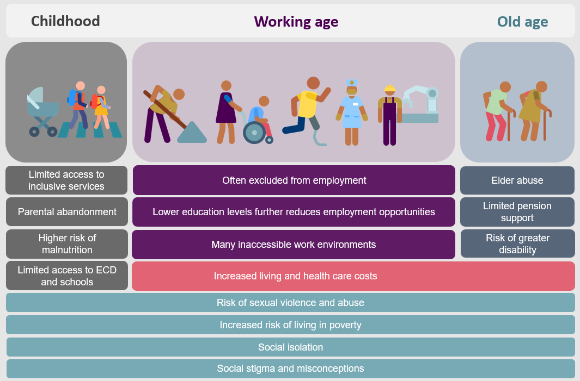
Source: Development Pathways.

Modern Comprehensive Social Security Systems
Modern, comprehensive social security systems offer income support to citizens throughout life, from birth to death, in line with international social security and human rights standards. This type of framework enables individuals to manage life events that impact income, including childbirth, job loss, sickness, disability, workplace injuries and ageing, and also helps people cope during unpredictable shocks or crises. These events often reduce people’s ability to earn an income and can negatively impact standards of living. For instance, a new mother may lose income while taking time off to care for her child, and sickness or injury may prevent work and lead to medical expenses. The ILO’s Social Security (Minimum Standards) Convention, 1952 (No. 102)—the flagship international standard for social security—outlines nine branches of social security that address key life events, namely: maternity benefits, family benefits (including child benefits), unemployment benefits, employment injury benefits, invalidity benefits, old-age benefits, survivors’ benefits and medical care. Figure 3-1 illustrates a modern, comprehensive social security framework, including disability benefits, complemented by poverty targeted social assistance for the poor.
Figure 3-1: A modern, comprehensive social security system with social security for all
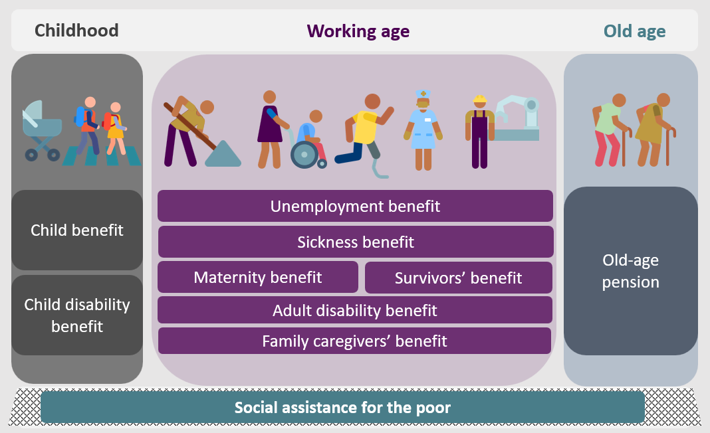
Source: Development Pathways.
In high income countries, average investment in social security (excluding health) reaches 16 per cent of gross domestic product (GDP), underscoring the value placed on robust social security systems. Recognising the significant benefits of expanding social security, a growing number of middle-income countries are following suit, developing comprehensive systems that prioritise child, old age and disability benefits, alongside small social assistance programmes for those living in poverty. There are currently 89 social security schemes in low- and middle-income countries that offer universal coverage.
Modern, comprehensive social security systems are multi-tiered, ensuring a minimum income and supporting consumption stability across the life course. At their core is the “social protection floor” concept (see Box 3-1), which guarantees a basic level of income security for all at nationally determined levels. This “first tier” of the system is financed by the government through general tax revenues, which means that all members of society contribute to the funding of these schemes through their taxes. In Jordan, most taxes are collected through sales and paid by everyone. Extension of the first tier is essential to cover all sections of the population.
Box 3-1: The social protection floor initiative
In 2016, governments around the world committed to the 2030 Agenda for Sustainable Development, comprising 17 Sustainable Development Goals. Under Goal 1, governments committed to eradicating poverty in all its forms, in part by establishing social protection systems for all, including floors (Goal 1.3). The social protection floor concept is derived from the ILO’s Social Protection Floors Recommendation, 2012 (No. 202) which frames principles for social protection floors, and provides guidance for their set up and maintenance. Three of the minimum guarantees in the social protection floor initiative aim to ensure everyone has access to basic income security throughout their lives:
- Basic income security for children: Provides financial support to ensure children can access nutrition, education and other essential services.
- Basic income security for working-age adults: Offers support for those unable to earn a sufficient income, for example, due to sickness, unemployment, maternity or disability.
- Basic income security for older adults: Ensures financial security for older persons.
This approach is designed to prevent or alleviate income insecurity and social exclusion by guaranteeing these basic protections, while also allowing for the gradual expansion of benefits to offer more comprehensive coverage over time.
The second tier is based on contributions from employees and employers, and participation is usually mandatory for those in formal employment, such as the schemes currently provided by the SSC. Many countries—including Jordan—rely on contributory social insurance for disability benefits. However, coverage tends to be low and often favours men, who are more frequently employed in the formal labour market and thus contribute to social insurance. “Tier three” involves voluntary schemes, usually provided by private companies but regulated by the government.
Figure 3-2: The three basic tiers of a modern, comprehensive social security system
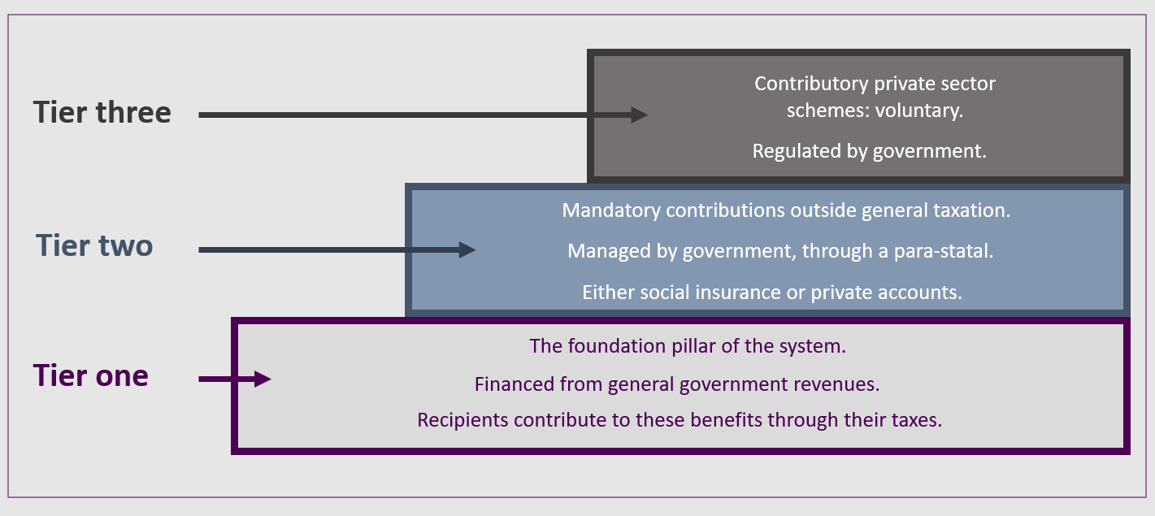
Source: Development Pathways.

Making Social Security Disability-Inclusive
Disability-inclusive social security systems have been present in high-income countries for several decades, and growing numbers of middle-income countries are also building them. This section describes good practice in the design of disability-inclusive systems and schemes (looking at each separately).

Good practice in the overall design of disability-inclusive social security systems
Based on global experience, there are various types of social security schemes that are relevant for persons with disabilities. They can provide or enhance income security across the different stages of life or cover additional disability-related costs. A well-designed disability-inclusive social security system typically includes two types of cash benefits:
- Disability-specific schemes: Schemes that are only offered to persons with disabilities, with eligibility based on a particular level of disability.
- Mainstream schemes: Schemes with eligibility criteria not linked to disability but for which persons with disabilities are usually eligible on the same grounds as others. In Jordan, this would include certain NAF and SSC benefits.
There is strong global evidence that, if countries rely only on mainstream social security schemes to provide income support to persons with disabilities, they will fail to provide adequate support. Instead, governments committed to offering persons with disabilities the support they require must provide disability-specific schemes as well as mainstream and disability-relevant schemes. This support should be accessible in childhood and adulthood, to address the kinds of challenges that are discussed in Section 2.
Based on international good practice, the core disability-specific and -relevant benefits that should be offered to persons with disabilities to address inequity and disadvantage, in addition to mainstream schemes, include (see Figure 4-1):
- Disability benefits for children to help families address the additional costs they face as well as a stipend for children with disabilities to help them cover the further costs of attending school.
- Disability pensions for people of working age who cannot or should not work and which replace income from work.
- Personal independence payments which compensate persons with disabilities for the additional costs they experience, so that they can enjoy equality of opportunity with people without disabilities.
- Old-age pensions that can replace the disability pension once people reach the age of eligibility for the pension.
- Support benefits that can be used to purchase care services, such as personal assistance by designated carers.
- Family caregivers’ benefits providing financial support for family carers who have experienced a loss of income due to their care responsibilities.
Figure 4-1: Disability-specific and -relevant benefits in a comprehensive social security system
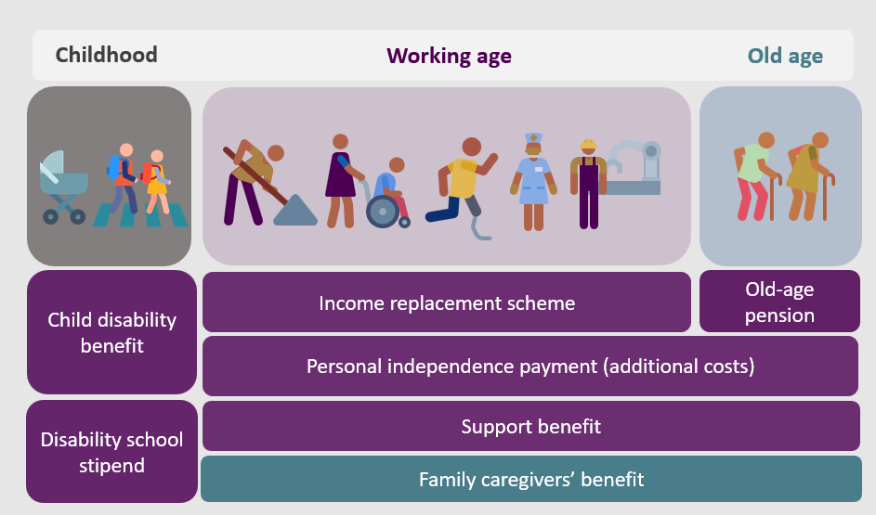
Source: Development Pathways.
The type of system outlined in Figure 4-1 is implemented in many high-income countries following decades of development. No low- or middle-income country has yet set up the full range of disability-specific and -relevant benefits. There is a particular challenge with the introduction of the personal independence payment since it requires a sophisticated disability assessment mechanism and strong administrative capacity.
Consequently, middle-income countries with relatively good disability-inclusive systems have developed a simpler system, comprising up to four types of core schemes: a child disability benefit (offered by around 30 low- and middle-income countries); a disability benefit for working age adults (around 50 countries); an old age pension; and, in a small number of cases (at least five countries), a caregivers’ benefit. Older adults with disabilities are more likely to receive financial assistance, as 65 low- and middle-income countries provide tax-financed old-age pensions. The disability benefit for working age adults is often designed to combine the aim of income replacement for those who cannot work, alongside compensation for disability-related costs for all persons with moderate and severe disabilities. Although an imperfect design, countries achieve these aims by providing persons with disabilities with variable transfer values: a higher value benefit for those with a severe disability and a lower value for those with a moderate disability.

Good practice in the design of disability specific and relevant schemes
When countries establish disability-specific social security schemes, global experience has indicated how best to design these schemes across a range of parameters. These parameters include: the identity of the recipient of the benefit, the inclusion of work requirements, the use of means testing, the type of disability assessment mechanism used and the value of the transfer.

Recipient of the transfer
Since disability-specific and old age benefits are for individuals, they should be paid to the recipient and not to the head of the household or family. This enhances the autonomy and dignity of persons with disabilities. Child disability benefits should be paid to the primary caregiver, and when children reach 18 years of age the payment should switch from their caregiver to the person with a disability.
If persons with disabilities are unable to manage their personal finances, a financial attorney should be appointed with approval from the relevant authority, often the courts. The attorney should assist in managing the individual’s bank account and financial affairs. It is crucial that these authorities respect the wishes of the recipient to the greatest extent possible. To minimise the risk of financial abuse, processes should be established that enable recipients to change their financial attorney whenever requested.

Work requirements
A challenge facing many persons with disabilities in low- and middle-income countries is that it is common for disability-specific benefits for working age people to be linked to capacity to work: in other words, benefits are only given to people who cannot work. This is often derived from the belief that disability equals incapacity, and it fails to recognise that most persons with disabilities are capable of working, as long as the environment is inclusive and accessible. Linking disability benefits for those of working age to incapacity to work excludes many persons with disabilities who can work—or are in employment—but who still need additional financial support to cover extra costs associated with having a disability.
There is some evidence that linking disability benefits to incapacity to work can generate work disincentives. For example, in South Africa, the Taylor Commission (2002) highlighted that the design of employability assessments for the Disability Grant disincentivises work, with only 10.3 per cent of grant recipients engaged in any employment. In contrast, 44 per cent of non-recipients with severe functional limitations were working. Research indicates that Brazil's means tested Benefício de Prestação Continuada programme has also seen a reduction in labour force participation among beneficiaries, illustrating that means testing can diminish incentives for both recipients and their family members to pursue employment.
Box 4-1: The challenge of determining incapacity to work
Determining incapacity to work is often misaligned with actual employment opportunities, as it is frequently assumed to be purely linked to an individual’s physical, intellectual or mental capacity. Effective assessments must take into account the broader environment. In South Africa, many recipients of the Disability Grant may be physically capable of working but are unable to secure employment due to high unemployment rates and discrimination, which can limit their job prospects. Consequently, the South African Social Security Agency recognises that work capacity assessments should reflect the realities of the labour market rather than focus solely on personal abilities. Similarly, in Mauritius, while it is assumed that beneficiaries of the Disability Benefit cannot work, there are no restrictions on employment in practice.
Source: Kidd et al. (2018); Wapling et al. (2022).
Governments face the challenge of designing social security systems that provide persons with disabilities the financial support they need, while also supporting them to take up and maintain employment. The personal independence payment has been designed to support those goals. It is not dependent on an individual's ability to work, but provides persons with disabilities with essential cash benefits. In countries where a single disability benefit serves both as an income replacement and as compensation for disability-related costs, it is important that no work requirement be applied, so that persons with disabilities can access support regardless of their employment status. However, where the system includes both a disability pension (for income replacement) and a separate personal independence payment, the disability pension should be accessed only for those unable or advised not to work, while all persons with disabilities, regardless of work status, should have access to the personal independence payment to help cover additional costs related to their disability.
Still, assessing individuals’ work capacity is complex and demands better coordination between benefit authorities, public employment services and other support agencies. For persons with disabilities, an individual case management approach can ease access to social security by helping them navigate these intricate systems. Expanding access to support services is also essential, particularly for those with partial work capacity who could benefit from tailored assistance. This flexible approach can adapt to changing needs, providing targeted support for individuals as they enter, transition within or exit the labour market.

The use of means testing
Universal disability schemes assess eligibility based on disability, yet while access to social security is a human right, many governments use targeting to decide who should receive disability benefits, reserving the cash transfers only for the poorest households. In low- and middle-income countries, there are notable variations: 28 disability benefits for working age adults are means-tested while 18 are universal. For children, 15 disability benefits are means-tested and 15 are universal. The use of means testing means that many persons with disabilities are excluded due to having incomes that are assessed as too high.
Global evidence shows that means testing is often inaccurate. In most countries, targeting errors exceed 50 per cent, resulting in many eligible individuals not receiving the support they need. Consequently, when means tests are applied to disability benefits or old age pensions, a substantial portion of those who need assistance are excluded.
Moreover, by applying means testing, countries risk overlooking the additional costs associated with disability that impact individuals regardless of income. Achieving true equality of opportunity requires access to financial support for all persons with disabilities, regardless of income. When support is conditional on income, many individuals are denied critical assistance, which can hinder their full participation in society, including access to employment.
Additionally, means testing can inadvertently create a disincentive for individuals with disabilities to seek employment, as higher earnings may lead to the loss of benefits. This not only perpetuates financial insecurity, but also limits their ability to engage fully in society.
A key design question when using poverty targeting for individual benefits, such as disability benefits and old age pensions, is whether to assess eligibility based on the individual’s income or that of the household. Social security is an individual right, yet if eligibility is determined by household income, people without any personal income might be deemed ineligible because of their household's financial situation. This approach infringes on an individual’s right to social security. To better protect this right and ensure access for persons with disabilities, it is more effective—and more compliant with human rights—to assess eligibility based on the individual’s income, as is done in South Africa. For child benefits, this assessment should consider only the caregiver’s income.

The type of disability assessment mechanism used
Even when disability-specific benefits are universal, coverage of eligible persons with disabilities is not guaranteed. For example, 27 per cent of persons with severe disabilities do not access Mauritius’s universal Basic Invalid Pension.
Under-coverage of eligible persons with disabilities, even when schemes are universal, points to the fact that there are other barriers that impede access, such as flawed disability assessment mechanisms. While it is widely acknowledged that the most effective way to assess disability is by evaluating both a person's impairment and the social and environmental factors that impact their ability to function in daily life, few countries adopt this comprehensive approach. Brazil stands out as a good practice example, involving both medical professionals and social workers in the assessment process. However, many countries continue to rely solely on medical assessments, which can exclude individuals with less severe impairments, even though their environments may significantly worsen the personal impacts of their disability.

Transfer values
The effectiveness of disability benefits depends on the value of transfers provided. Figure 4-2 shows the monthly value of disability-specific benefits for working-age adults across 37 low- and middle-income countries (using the highest value for those schemes offering multiple transfer values). The value of transfers varies considerably between countries, from 1.75 per cent of GDP per capita in Cambodia to 40 per cent in Kiribati. The median transfer value is 13.9 per cent of GDP per capita while 11 countries have a transfer value greater than 20 per cent of GDP per capita. For reference, in Jordan today, GDP per capita is JOD3,300 (US$4,600) 1.75 per cent of GDP per capita would amount to JOD5 per month, 13.9 per cent would be JOD38, 20 per cent would be JOD55, and 40 per cent would amount to JOD111 per month.
Figure 4-2: Value of tax-financed disability-specific benefits for working-age adults as a percentage of GDP per capita, across a range of low- and middle-income countries
Source: Development Pathways Disability Database (Development Pathways 2019), internal disability benefit databases developed by Development Pathways (2022) and the Asian Development Bank’s recent country specific social protection index reports.
The limited transfer values found in many countries reduce the effectiveness of disability benefits, though they still provide some level of support. In Viet Nam, for example, the disability benefit is relatively high compared to many other countries, yet recipients express that it is too little to make a meaningful impact. Even in countries with higher transfer values, research has shown that these amounts can be insufficient. In South Africa, while the Disability Grant is substantial enough to cover basic subsistence needs, it fails to address the additional costs associated with disability. Furthermore, around 25 per cent of households receiving the grant experienced hunger in the previous year, compared to 16 per cent of the general population, and one-third of these households reported running out of money to buy food, compared to one-fifth of the general population. Similarly, in Nepal, despite a relatively higher transfer value, recipients still found the benefit inadequate.
Good practice in middle-income countries with relatively effective disability-specific schemes suggests indicative guidance for their transfer values:
- When working age disability benefits provide variable transfer values, the highest transfer is set at the value of the old age pension. This is because the benefit has the same purpose as an old age pension, which is to provide a minimum income to those who may not be able to work. When lower values are provided to those with moderate disabilities, the amount varies between countries. But, given that the aim is to compensate those who can work for the additional costs they face, around half the value of the highest transfer is a reasonable guideline for a simple system.
- The highest value for a child disability benefit is often also set at the value of an old age pension, since it is meant to cover the significant additional costs that children with severe disabilities face and ensure they enjoy a good start in life. Additionally, child disability benefits sometimes compensate for loss of work when a separate caregiver benefit is not provided. For those with a moderate disability, the value could be aligned to that of the working age adult disability benefit for those with a similar level of disability.
- Caregivers’ benefits are intended to compensate family members who have given up work to care for a person with a profound disability. Therefore, it should be set at the same value as an old age pension.

Conclusion
A high proportion of Jordan’s population is affected, either directly or indirectly, by disability. Further, many persons with disabilities in Jordan are struggling with the additional disability-related costs that they experience. The National Social Protection Strategy for 2019-2025 recognises that all persons with disabilities should be able to access social protection. The provision of a comprehensive system of disability-specific benefits and an old age pension could transform the lives of persons with disabilities—and older persons—across Jordan.
This briefing note has explored international best practices in disability-inclusive social security, highlighting the components of a comprehensive and high-quality framework. To develop a truly disability-inclusive social security system in Jordan, the government might consider shifting its social protection policy towards a multi-tiered approach to social security, based on a social protection floor. This shift would involve introducing tax-financed disability benefits and disability-specific schemes that address the diverse needs of persons with disabilities. By integrating these benefits with disability-relevant programmes, such as old-age pensions, and ensuring that mainstream schemes are accessible to all, Jordan can create a more equitable system. Embracing global best practices in the design and implementation of these benefits will be crucial for enhancing the dignity and autonomy of persons with disabilities, as well as encouraging their full participation in society.

Bibliography
Alkhatib, E. (2022). Overview of the Challenges Facing the Realisation of Accessibility for Persons with Disabilities in Jordan. West Asia-North Africa Institute. https://wanainstitute.org/sites/default/files/publications/Overview%20of%20the%20Challenges%20Facing%20the%20Realisation%20of%20Accessibility%20for%20Persons%20with%20Disabilities%20in%20Jordan%20Enas%20Alkhatib_0.pdf
Arab Barometer. (2024). Arab Barometer VIII: Jordan Report. https://www.arabbarometer.org/wp-content/uploads/ABVIII_Jordan_Report-Public-Opinions-EN-1.pdf
Arab Barometer. (2024). Arab Barometer Wave VIII (September 2023 - July 2024)‎: Data Sets. https://www.arabbarometer.org/survey-data/data-downloads/#.
Atkinson, A. B. (2005). The Atkinson Review: Final Report: Measurement of Government Output and Productivity for the National Accounts. Palgrave Macmillan.
Banks, L. M. & Polack, S. (2014). The Economic Costs of Exclusion and Gains of Inclusion of People with Disabilities: Evidence from Low and Middle Income Countries. ICED, CBM & LSHTM. https://www.cbm.org/fileadmin/user_upload/Publications/Costs-of-Exclusion-and-Gains-of-Inclusion-Report.pdf
Banks, L.M., M. Walsham, Sh. Neupane, Sa. Neupane, Y. Pradhananga, M. Maharjan, K. Blanchet et al. (2018). “Disability-inclusive social protection in Nepal: A national overview with a case study from Tanahun district,” International Centre for Evidence in Disability Research Report, London.
Bernabe-Ortiz, A., Kuper, H., Walsham, M., Mactaggart, I., Blanchet, K. and Vasquez, A. (2015). Applied research concerning inclusion of persons with disabilities in systems of social protection: Quantitative Research Report, Peru. GIZ.
Department of Statistics Jordan. (2013). Household Expenditures & Income Survey 2013-2014. https://dosweb.dos.gov.jo/product/household-income2013-2014/
Department of Statistics Jordan. (2021). The Reality of Disability: “Functional Difficulties” in Jordan, based on the data of The General Population and Housing Census 2015. Government of Jordan. https://dosweb.dos.gov.jo/DataBank/Analytical_Reports/Disability_2021.pdf
Department of Statistics (DoS) [Jordan] and ICF. (2024). Jordan Population and Family and Health Survey 2023. Amman, Jordan, and Rockville, Maryland, USA: DoS and ICF.
De Koker, C., L. de Waal and J.H. Vorster (2006), “A profile of social security beneficiaries in South Africa”. Commissioned research for the National Department of Social Development, Department of Sociology and Social Anthropology, University of Stellenbosch, Stellenbosch.
Faqir, S. (2024, August 14). Road to inclusion: highlighting challenges faced by disabled people. The Jordan Times. https://jordantimes.com/news/local/road-inclusion-highlighting-challenges-faced-disabled-people
Goldblatt, B. (2009), “Gender, rights and the disability grant in South Africa”. Development Southern Africa, 26 (3), 369–84. https://ideas.repec.org/a/taf/deveza/v26y2009i3p369-382.html
ILO. (2021). Building social protection systems: International standards and human rights instruments International Labour Office. International Labour Organization: Geneva. https://www.ilo.org/publications/building-social-protection-systems-international-standards-and-human-rights
ILO. (2024). World Social Protection Report 2024-26: Universal social protection for climate action and a just transition. https://www.ilo.org/sites/default/files/2024-09/WSPR_2024_EN_WEB_1.pdf
International Monetary Fund (IMF). (2024). IMF Datamapper. https://www.imf.org/external/datamapper/profile/JOR.
Kassouf, L. and de Oliveira, P.R. (2012). Impact Evaluation of the Brazilian NonContributory Pension Program Benefício De Prestação Continuada (BPC) on Family Welfare. Partnership for Economic Policy Working Paper 2012-12.
Kidd, S. & Athias, D. (2020). Hit and Miss: An assessment of targeting effectiveness in social protection with additional analysis. (Development Pathways Working Paper: June 2020). https://www.developmentpathways.co.uk/publications/hit-and-miss-an-assessment-of-targeting-effectiveness-in-social-protection/
Kidd, S., Athias, D. & Seglah, H. (2023a). Social security for persons with disabilities across low- and middle-income countries: an overview on lessons learnt and pathways toward greater inclusivity. In L. Patel, S. Plagerson & I. Chinyoka (Eds.), Handbook on Social Protection and Social Development in the Global South. https://doi.org/10.4337/9781800378421.00040
Kidd, S., Mansoor, N. & Barca, A. (2023b). An affordable and feasible pathway to universal social security using the principle of universality. Development Pathways, ACT Church of Sweden & Action Against Hunger. https://www.developmentpathways.co.uk/publications/affordable-feasible-pathway-to-universal-social-security/
Kidd, S., Wapling, L., Bailey-Athias, D. and Tran, A. (2018). Social Protection and Disability in South Africa. Development Pathways Working Paper. Study funded by DFID (UK Aid). https://www.developmentpathways.co.uk/publications/social-protection-and-disability-in-south-africa/
Kidd, S., Wapling, L., Schjoedt, R., Gelders, B., Athias, D., Tran, A. & Saloman, H. (2019). Leaving No-one Behind: Building Inclusive Social Protection Systems for Persons with Disabilities (Development Pathways Working Paper: February 2019). Orpington. https://www.developmentpathways.co.uk/wp-content/uploads/2019/04/Disability-overview-report-2019April07.pdf
Mitra, S. (2010). Disability Screening and Labor Supply: Evidence from South Africa. American Economic Review Papers and Proceedings, 99(2): 512-516.
Mitra, S., Palmer, M., Kim, H., Mont, D. & Groce, N. (2017). Extra costs of living with a disability: A review and agenda for research. Disability and Health Journal, 10(4), 475-484. https://doi.org/10.1016/j.dhjo.2017.04.007
Mont, D. (2023). Estimating the extra disability expenditures for the design of inclusive social protection policies. Frontiers in Rehabilitation Sciences, 4(1179213). https://doi.org/10.3389/fresc.2023.1179213
Mutasa, G. (2012). Disability Grant and Individual Labour Supply: Evidence from South Africa. PhD thesis on the Disability Grant and Labour Supply in South Africa, School of Economics, University of Cape Town.
Shamil. (2024). The definition of social protection. Shamil briefs: Paper 1 (February 2024). https://www.developmentpathways.co.uk/wp-content/uploads/2024/03/Brief-1-Definition-of-Social-Protection.pdf
Tran, A. (2021), How Effective Are Pension Systems In Ensuring A Minimum Income In Old Age? An Index To Measure Global Progress. Pathways Perspectives on Social Policy in International Development, Issue No. 33. London. https://www.developmentpathways.co.uk/wp-content/uploads/2021/03/Pathways-Perspectives-Pensions-UpdateMar15.pdf
UNFPA. (2024). Country profile: The rights and wellbeing of older persons in Jordan. United Nations Population Fund. https://arabstates.unfpa.org/en/publications/rights-and-wellbeing-older-persons-jordan
UNICEF. (2020). Building a national social protection system fit for Uzbekistan’s children and youth. United Nations Children’s Fund. https://www.unicef.org/uzbekistan/en/reports/building-national-social-protection-system-fit-uzbekistans-children-and-youth
Wapling, L., Schjoedt, R. & Cretney, M. (2022). Social protection and disability in Mauritius. Development Pathways Working Paper. Study funded by DFID (UK Aid). https://www.developmentpathways.co.uk/publications/social-protection-disability-mauritius/
Wapling, L., Schjoedt, R. & Kidd, S. D. (2020). Social protection and disability in Brazil. Development Pathways Working Paper. Study funded by DFID (UK Aid). https://www.developmentpathways.co.uk/wp-content/uploads/2020/02/Social-Protection-and-Disability-in-Brazil-1.pdf
Watson, C. (2015), “Assessing the impact of selected social assistance programmes in Viet Nam”. Background paper produced for UNDP and MOLISA.

In Jordan, this would include the National Aid Fund (NAF).
This includes the various pensions available to workers in formal employment under Jordan’s Social Security Corporation (SSC).
The Universal Declaration of Human Rights (UDHR) and the International Covenant on Economic, Social and Cultural Rights (ICESCR) both recognise the right to social security for all individuals, including those with disabilities. Additionally, the Convention on the Rights of Persons with Disabilities (CRPD) which Jordan ratified in 2008 specifically highlights the obligation of States Parties to promote, protect and ensure full inclusion of persons with disabilities in society, including through comprehensive social protection measures.
DoS and ICF (2024). Jordan Population and Family Health Survey (JPFHS) 2023. The JPFHS included the Demographic and Health Survey (DHS) Programme’s Disability Module which uses questions developed by the Washington Group on Disability Statistics (WG). The WG is framed using the World Health Organization (WHO) international Classification of Functioning, Disability and Health. Questions address the degree of difficulty a person over five years of age experiences when performing one of six areas of functioning: seeing, hearing, walking, cognition, self-care and communication. The degree of difficulty is self-reported by survey respondents. ”Mild disability” means a person reports having “some difficulty” in an area; “moderate” means they report “a lot of difficulty;” and “severe” means they “cannot do [a function] at all.”
Ibid.
UNFPA (2024).
DoS and ICF (2024).
When asked whether their household had run out of food before they had money to buy more, 22 per cent said this was often true, and 39 per cent said this was sometimes true in the previous 30-day period. Note that the report states 27 per cent said this was often true and 40 per cent said this was sometimes true, but based on the provided survey data, the correct figures appear to be 22 and 39 per cent, respectively.
Mont (2023).
Kidd et al. (2023a).
Analysis based on the Household Expenditure and Income Survey (DoS 2013), with results adjusted for inflation. This estimate used the standard of living approach to calculate the additional costs, with monthly household consumption as the welfare measure.
DoS (2021); Alkhatib (2022); Faqir (2024).
ILO (2021).
ILO (2024).
See: https://www.ilo.org/universal-social-protection-department/areas-work-social-protection-department/policy-development-and-applied-research/social-protection-floor.
Kidd et al. (2023a).
Kidd et al. (2019).
Tran (2021).
Kidd et al. (2018).
Kassouf & de Oliveira (2012).
Kidd et al. (2023a).
Kidd & Athias (2020).
Kidd et al. (2018).
Wapling et al. (2022).
Kidd et al. (2019).
Wapling et al. (2020).
IMF Datamapper (2024). https://www.imf.org/external/datamapper/profile/JOR.
Kidd et al. (2023a).
Watson (2015).
Goldblatt (2009).
De Koker et al. (2006).
Banks et al. (2018).

