

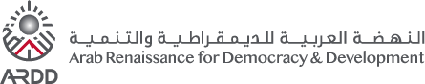
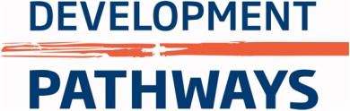
Good Practice in Disability-Inclusive Social Security
Accessible Briefing Note

https://www.developmentpathways.co.uk/
December 2024

Introduction
Social security is an important public service that helps people get money regularly. It also protects people from not having enough money or being at risk from problems when they are not working, or are old, sick or disabled. Social security is money that the government can give to all people who live in their country if they need it. This money helps people in two ways. The first way it helps is that it gives a basic amount of money to support people. The second way this money helps is to support people to keep getting similar amounts of money at different times of their life, so that even when their life changes, they have enough money to look after themselves. The government gets this money to give to people through taxes and also by getting people to save some of their money regularly through social security programmes. Social security is one part of social protection, the other part is social services. These parts are explained in Figure 1-1.
Figure 1-1: The meaning of social protection as two important public services
Social protection is made up of two important public services for people:: social security (money support) and personal social services (help people need to take care of themselves and other support with everyday life). This brief covers social security only.
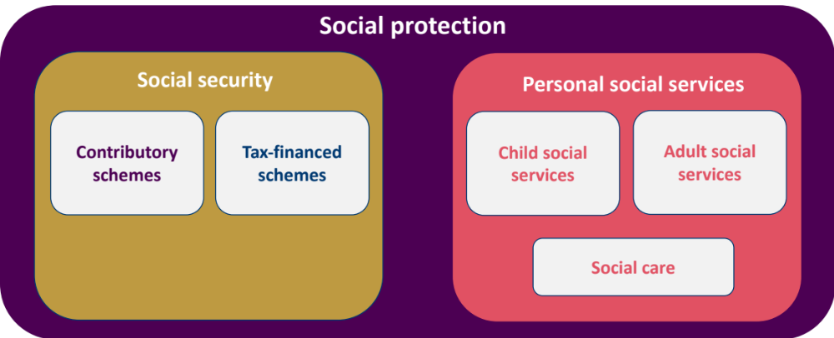
Source: Shamil (2024). The definition used by Shamil comes from international standards of classification of public services.
Persons with disabilities often require support in many different areas, as shown by Figure 1-2. This support might include:
- Finding out what help or support a person with a disability may need as soon as possible, like in childhood;
- Support with health;
- Training and support to help with skills lost because of injury or disability;
- Tools and devices to assist with daily living;
- Home adaptations; and
- Getting around.
Social protection is also a type of support that people need. This includes both money support and other support people need with everyday life. It is important to know that the support needs of every person can be different.
Figure 1-2: Persons with disabilities need support from many different services
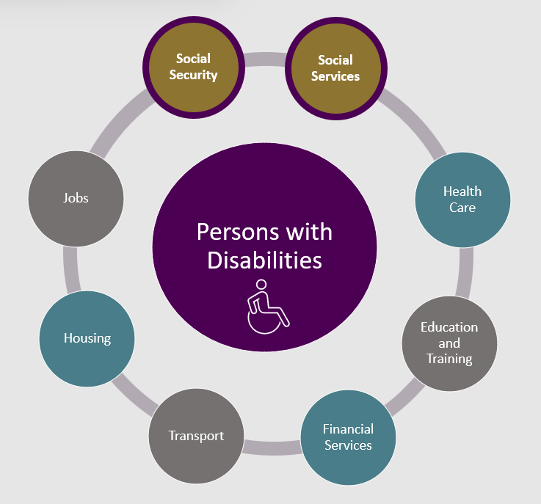
Source: Development Pathways.
Social security is an important human right, that everybody should be able to have when they need it at any time in their life. For persons with disabilities, this right is explained in several international agreements made about disability rights and workers’ rights.
Making social security disability-inclusive means making sure that persons with disabilities can get social security as easily as other people. There must also be types of social security that are specifically for persons with disabilities and that help stop the difficulties they face. Social security systems should make sure that:
- Persons with disabilities can get money support as easily as other persons;
- Additional support is given to help with extra costs that persons with disabilities have;
- Support is provided that can be changed easily to meet different needs of persons with disabilities and their families;
- Persons with disabilities can join social security programmes as easily as other persons;
- The help given aims to stop the difficulties that persons with disabilities experience, treats persons with disabilities with respect and does not stop them from accessing support.
This briefing note explains the difficulties persons with disabilities can experience all through their lives and how social security can help stop them. It also explains what are good examples of disability-inclusive social security systems in different countries and what a strong social security system looks like.

Social Security: a Tool to Stop Challenges Faced by Persons with Disabilities
There is a good reason to invest in a social security system that includes persons with disabilities in Jordan. According to a survey called the 2023 Demographic and Health Survey, 14% of all people in Jordan have a disability, with 3.5% having moderate or severe disabilities. As people get older, disabilities become more common. The highest rates of disability are in those aged 80 and older. However, because there are a lot of young people in Jordan, the highest overall number of persons with a disability are aged 20-29. In the future, the number of people in Jordan aged 60 years and older is expected to increase by more than double to 620,000 people in 2020 (six per cent of all people in Jordan) to 2.15 million by 2050 (16.6 per cent of all people in Jordan). When this happens, it is expected that the overall number of persons with disabilities in Jordan will increase.
Figure 2-1: How common disability is in Jordan for people of different in Jordan by ages
Source: DoS and ICF (2024). Note: Disability prevalence is only reported for individuals aged five years and above.
Looking only at how many persons with disabilities there are means we may miss how disability impacts the ability of individuals to take part in society, as well as how it impacts families and communities. For example, 9% of all people in Jordan live in homes that include someone who has a disability that causes them a lot of or extreme difficulty.
Having a disability and not having enough money to meet basic needs like food are strongly related to each other, with each making the other worse. Many persons with disabilities and their families live on small and unreliable amounts of money (see Figure 2-2). A recent survey found that 61 per cent of all people in Jordan say that they have difficulty giving their families enough food to last to the end of the month.
Things like not being able to get healthcare, an education, or having a poor living situation can increase the risk of getting a disability. At the same time, having a disability can make it harder for people to make their lives better because disability may limit people’s ability to take part in work and within their community. Good services like health care, education, and social security can help people with disabilities and their families live better lives and join in the economy. If governments do not provide social security for persons with disabilities, it is a missed chance for individuals to succeed and for the economy to grow. Giving persons with disabilities access to many support services including social security can break the relationship between not having enough money and having a disability.
Figure 2-2: The relationship between having a disability and not having enough money
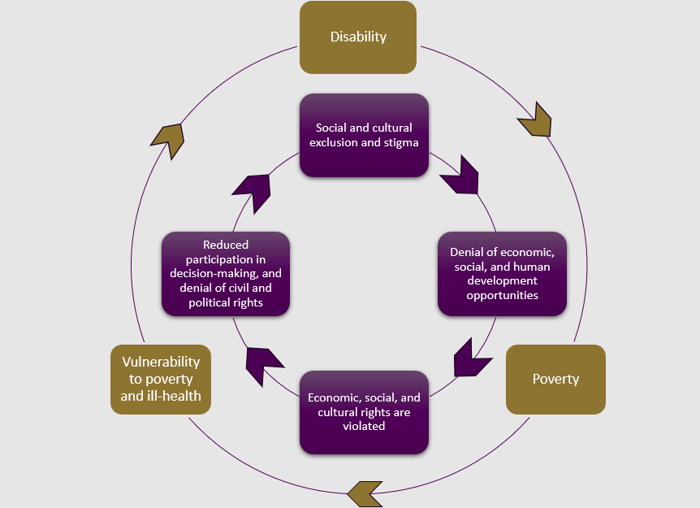
Source: Kidd et al. (2019), based on Figure 1 in Banks & Polack (2014).
When thinking about the living situation of persons with disabilities it is important to consider the extra costs they experience because of their disability. These costs are different based on what each person needs and the environment around them. Extra costs include things like health care, tools and devices to assist with daily living, education, transport, home changes, and personal care. Direct costs include things like transport, tools and devices to assist with daily living, diapers, or medicine. Persons with disabilities may also have less money due to difficulties in education and work because of their disability. Family members might also have less money because they reduce their work hours or stop working to care for someone with a disability. These are indirect costs of disability as they come from lost opportunities to make money.
Homes in which a family member has a disability can have high extra costs. Globally, these costs can range from 8% to 58% of the total amount of money that a family spends on the things they need. An initial analysis for Jordan suggests that disability-related costs may be 13.7% of the total amount of money a home earns on average. This is explained in Figure 2-3. Therefore, a normal household with a family member who has a disability would need an additional JOD 152 (about US$214) per month to have the same lifestyle as another similar household without a person with a disability.
Figure 2-3: The additional costs of disability and their impacts on living situations.
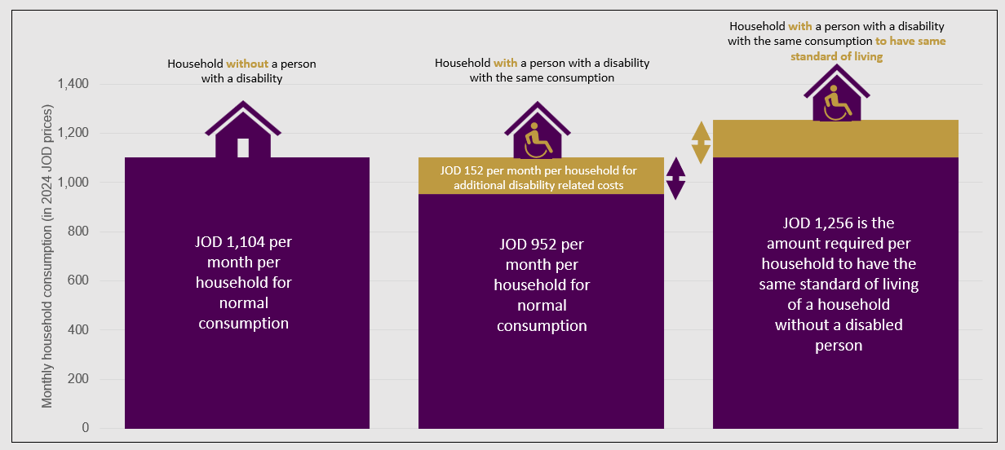
Source: Development Pathways.
As well as experiencing extra costs, persons with disabilities face difficulties all through their lives that lead to money problems, poor living situations and an increased need for social security. Figure 2-4 explains these common difficulties, which could be stopped or reduced by receiving social security. In Jordan, these challenges come from barriers in society, like old transport systems, not enough support, negative attitudes from other people, and places that are hard to access for persons with disabilities. Because of this, persons with disabilities have less access to education, jobs, and opportunities to spend time with friends and family. This limits their independence and chances to learn new skills.
Figure 2-4: Common challenges faced by persons with disabilities across their lives
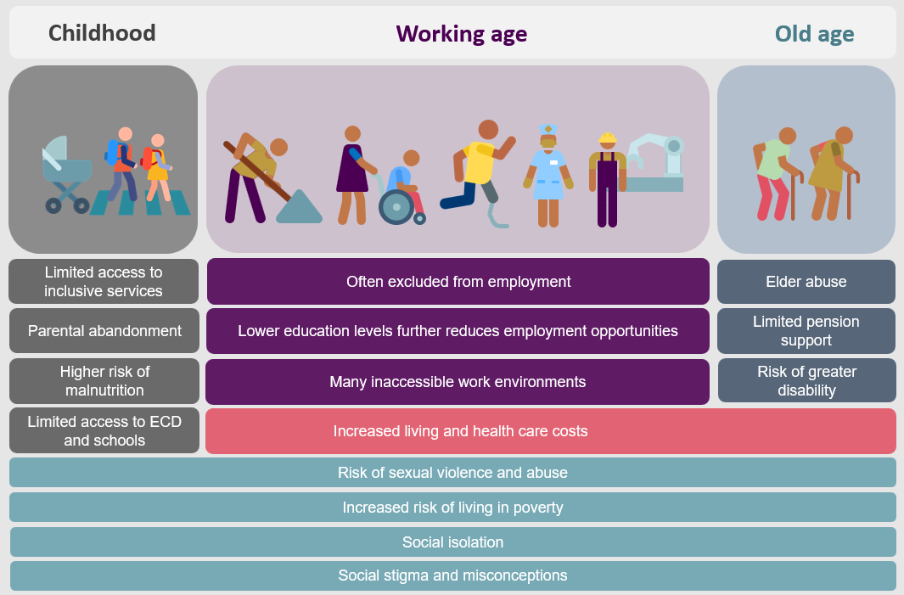
Source: Development Pathways.

Modern Comprehensive Social Security Systems
Modern social security systems support people throughout their lives, from birth to old age, following international standards for social security and human rights. These types of systems help people to cope with life events that impact the amount of money they get, like having a baby, losing a job, getting sick, becoming disabled, experiencing an injury at the workplace, or getting older. They also help people deal with sudden unexpected events. These events can stop people from getting money and can negatively impact their lives. For example, a new mother might stop getting money while caring for her baby and sickness or injury might stop someone from working and cause medical costs. The International Labour Organization (ILO) created the Social Security (Minimum Standards) Convention, 1952 (No. 102), which is a key international agreement for social security. It lists nine types of support for important life events: motherhood benefits, family and child benefits, unemployment benefits, employment injury benefits, benefits for people who cannot work due to disability, old-age benefits, benefits for people whose family member has died and medical care. Figure 3-1 illustrates a modern, social security system, including disability benefits, that is joined up with a social assistance programme for people who are poor.
Figure 3-1: A modern, comprehensive social security system with social security for all
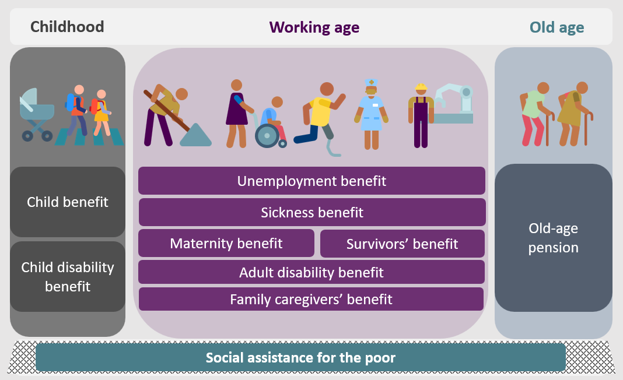
Source: Development Pathways.
In high-income countries, governments spend about 16% of their GDP on social security (not including health care). This shows how important strong social security systems are. Because of the benefits of social security, many middle-income countries are expanding their social security systems. These systems focus on benefits for children, older persons, and persons with disabilities. They also include small programmes to help people living in poverty. There are currently 89 social security programmes in low- and middle-income countries that try to cover everyone in the country.
Modern social security systems have multiple levels. They make sure people have a basic income and stable support throughout their lives. The key part of these systems is the "social protection floor" shown in Box 3-1. This provides a minimum amount of money for everyone, decided by each country. The first level of these systems is funded by taxes collected by the government. This means everyone contributes to the system by paying taxes. For example, in Jordan, most taxes come from sales, which everyone pays. Expanding this first level is important to ensure that everyone in the country is included.
Box 3-1: The social protection floor initiative
In 2016, countries around the world agreed to the 2030 Agenda for Sustainable Development. This includes 17 goals, called the Sustainable Development Goals (SDGs). Goal 1 focuses on ending poverty everywhere. As part of this goal, governments promised to set up social protection systems for everyone, including social protection floors (Goal 1.3).
The idea of social protection floors comes from the International Labour Organization's (ILO) 2012 guidance (Recommendation No. 202) which outlines their key parts and explains how to set them up. These floors aim to ensure everyone has a basic amount of money and throughout their lives, three key guarantees are:
- A basic amount of money for children: To help to make sure children get enough healthy food, education, and other important services.
- A basic amount of money for working-age adults: to support those who cannot earn enough money because of sickness, unemployment, motherhood, or disability.
- A basic amount of money for older adults: To provide older people with enough money.
This system helps stop situations where people do not have enough money and are excluded from society. It starts with basic protections and can grow to include more benefits over time.
The second level of social security comes from payments made by workers and employers. People who have official jobs recognised by the government usually have to take part in these programmes. For example, in Jordan, the Social Security Corporation (SSC) runs these programmes, which include disability benefits. However, these programmes often reach less people, as many persons work in jobs that are not officially recognised by the government. Men are more likely to benefit from these programmes because they more often work in official jobs recognised by the government. The third level includes voluntary schemes. These are usually offered by private companies but are managed by the government.
Figure 3-2: The three basic levels of a modern, comprehensive social security system
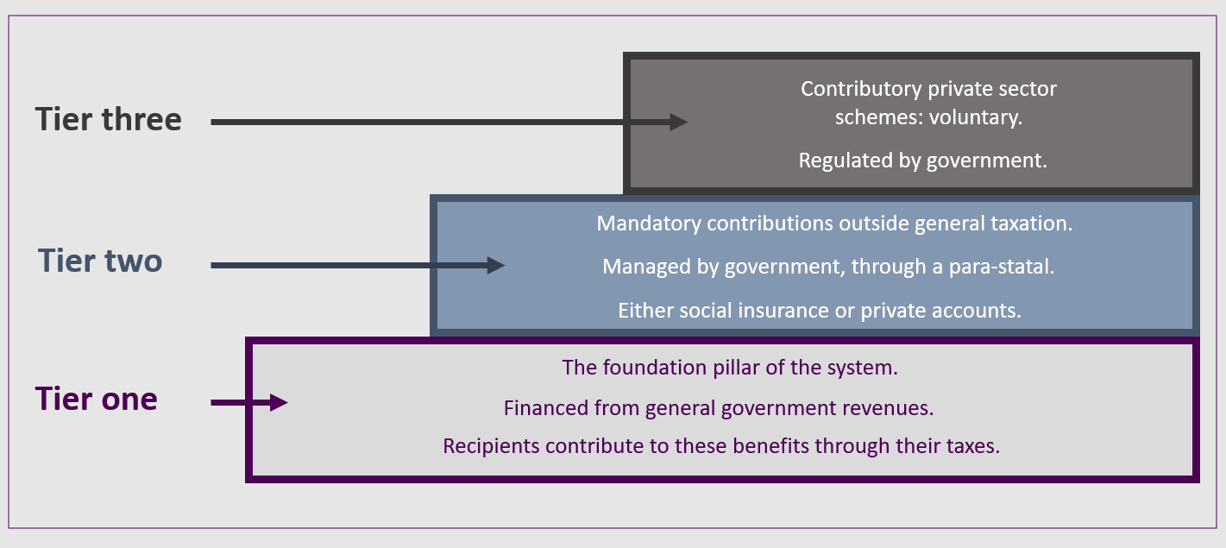
Source: Development Pathways.

Making Social Security Disability-Inclusive
Disability-inclusive social security systems have existed in high-income countries for many years, and more middle-income countries are starting to create them as well. This section will explain examples of good practices in creating systems and programmes that include persons with disabilities, looking at each system and programme separately.

Good practice in the overall design of disability-inclusive social security systems
There are different social security systems that exist around the world that can support persons with disabilities.
- Disability-specific programmes: These are programmes that are only for persons with disabilities. To join, a person needs to have a certain level of disability.
- Mainstream programmes: These are programmes open to everyone, not just persons with disabilities. However, persons with disabilities can join these programmes just like anyone else. In Jordan, this includes programmes like the NAF (National Aid Fund) and many provided by the SSC (Social Security Corporation).
There is strong evidence worldwide that if countries only use general social security programmes to give persons with disabilities money support, they will not provide the amount of support needed. To truly help persons with disabilities, governments need to offer both programmes designed only for persons with disabilities as well as more general programmes that are also useful for people with disabilities. This support should be available from childhood through adulthood to address the difficulties discussed in Section 2.
Based on good examples from different countries, the main benefits that should be provided to people with disabilities to help them with their difficulties along with more general help include:
- Disability benefits for children: These help families pay for extra costs they experience because of their child's disability, plus give extra money for children with disabilities to help with the costs of going to school.
- Disability pensions: These are payments for people of working age who cannot work or should not work, and these payments replace the money they would have got from working.
- Personal independence payments: These payments help persons with disabilities pay for general extra costs they have, so they can have the same opportunities as persons without disabilities.
- Old-age pensions: When people get older and are can get an old-age pension, this payment replaces the disability pension.
- Support benefits: These benefits can be used to pay for care services, like personal help from carers.
- Family caregivers benefits: These are payments for family members who take care of someone with a disability and earn less money because of their caregiving duties.
Figure 4-1: Disability-specific and -relevant benefits in a comprehensive social security system
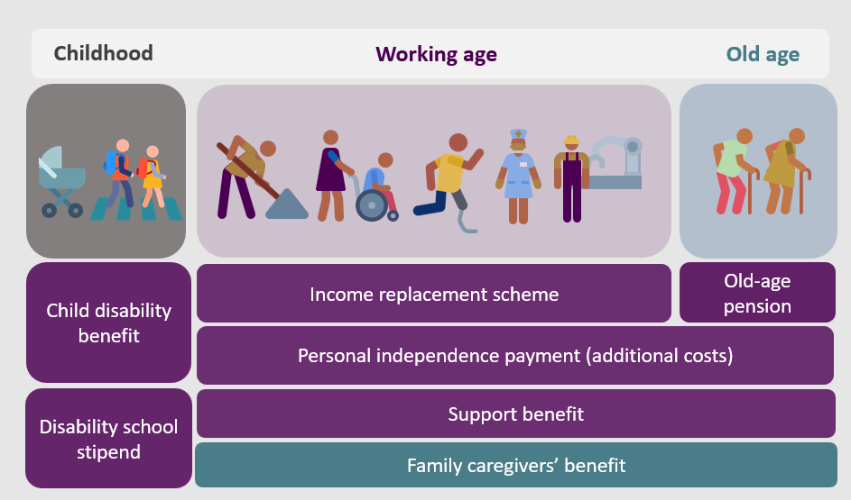
Source: Development Pathways.
The system shown in Figure 4-1 has been made in many high-income countries over many years of development. No low- or middle-income country has fully set up all of the benefits for people with disabilities. One big difficulty is the introduction of personal independence payments because it needs a strong system to identify the type and level of someone’s disability as well as good management to make it work well.
Middle-income countries with good systems for persons with disabilities have created simpler support programmes, usually made of up to four main types of benefits:
- Child disability benefit: Given in around 30 low- and middle-income countries.
- Disability benefit for working-age adults: Available in about 50 countries.
- Old-age pension: Available for older adults, with 65 countries providing these pensions.
- Caregivers’ benefit: Given in at least five countries to support family caregivers.
Older adults with disabilities are more likely to receive help, as many countries provide old-age pensions. The disability benefit for working-age adults aims to replace money for those who cannot work, and also to help with extra costs caused by disability for persons whose disability causes a lot of or extreme difficulty. Though not perfect, countries meet these aims by offering different levels of support: a higher benefit for persons whose disability causes extreme difficulty and a lower benefit for those whose disability causes a lot of difficulty.

Good practice in the design of disability-specific and relevant schemes
The best ways to design social security programmes for persons with disabilities in different areas has been shown by countries who have already set up these programmes. These areas include who receives the benefit, whether rules that say persons who get support have to work are included, if and how countries look at how much money someone already has, how countries identify the type and level of someone’s disability, and the amount of benefit given.

Who is given the benefit
Disability and old age benefits should go directly to the person getting them, not to the head of the household. This helps persons with disabilities keep their independence and dignity. For children with disabilities, the benefit should be paid to the main person who looks after them. When the child turns 18, the payment should go directly to them.
If someone with a disability cannot manage their money independently, a person should be officially chosen by a law court to help (called a financial attorney). This attorney would manage the person’s bank account and money. It is important that this financial attorney follows the wishes of the person with a disability as much as possible. To avoid the money being used incorrectly, there should be rules that give persons with disabilities the power to change their financial attorney if needed.

Rules about working
A problem for many persons with disabilities in low- and middle-income countries is that disability benefits for working-age adults are often only given to those who cannot work. This idea comes from the belief that disability means a person cannot work, but this is not true for most persons with disabilities. They can work if the environment is inclusive and easy for them to access. When disability benefits are connected to not being able to work, this leaves out many persons with disabilities who can work or already have jobs but still need extra help with money to cover the extra costs of having a disability.
Some evidence shows that linking disability benefits to the ability to work can stop people from seeking work. For example, in South Africa, an investigation found that the way someone’s ability to work was tested for a benefit called the Disability Grant made people less likely to work. Only 10.3% of people who got the benefit were working, compared to 44% of people with serious disabilities who did not receive the benefit. In Brazil, the Benefício de Prestação Continuada programme has also led to fewer people working. This programme involves testing people to see how much money they already have, known as means-testing. This programme shows that means testing can make both the person receiving benefits and their family members less eager to find a job.

Box 4-1: The challenge of determining lack of ability to work
Testing whether someone is unable to work is often based only on their physical, mental, or learning abilities, which does not always match real job opportunities. Good assessments need to consider the wider environment. In South Africa, many people who receive a benefit called the Disability Grant are physically able to work but cannot find jobs because of high unemployment and discrimination. This makes it harder for them to get a job. The part of government who manages this programme called the South African Social Security Agency understands that testing work ability should focus on the reality of jobs available, not just personal abilities. Similarly, in Mauritius, while it is assumed that people receiving a benefit called the Disability Benefits cannot work, there are no actual rules preventing them from working.
Source: Kidd et al. (2018); Wapling et al. (2022).
Governments face the difficulty of creating social security systems that give persons with disabilities the help with money they need while also supporting them in finding and keeping a job. The personal independence payment aims to help with both of these goals. It does not depend on whether a person can work, but provides cash benefits that persons with disabilities need. In countries where there is a single disability benefit that replaces the money people would get from work and covers disability-related costs, no work requirement should be applied. This allows people with disabilities to get support, no matter if they are working. However, in systems with both a disability pension (for replacing lost money from work) and a personal independence payment (for extra disability costs), the disability pension should only be given to people who cannot work or are advised not to work. At the same time, all persons with disabilities, whether they work or not, should receive the personal independence payment to help cover extra costs caused by their disability.
Testing a person’s ability to work is difficult and needs better communication between parts of government who manage giving benefits, services that support people with work, and other support agencies. For persons with disabilities, an approach that considers their personal needs can help them get social security more easily by guiding them through these difficult systems. Expanding access to support services is crucial, especially for those who can do work some of the time and could benefit from assistance that meets their individual needs. This support should change as the person’s needs change, offering support for a person’s individual situation as they start work, change jobs, or stop working.

Testing how much money someone has
Programmes that give benefits to all persons with disabilities, give the benefits based on whether someone has a disability. However, even though social security is a human right, many governments use the amount of money families have to decide who should receive benefits, giving money support only to the poorest households. In low- and middle-income countries, there are differences: 28 disability benefits for adults of working age test how much money they have (called means-testing), while 18 are for everyone (universal). For children, 15 benefits are means-tested, and 15 are universal.
Because of means testing, many persons with disabilities are left out because their earnings are considered too high.

Evidence from different countries shows that means testing often does not work well. In many countries, more than 50% of people who need help do not get it. When means tests are used for disability benefits or old age pensions, many people who need support are left out.
By using means testing, countries may miss the extra costs of living with a disability, which impact every person with a disability, no matter the amount of money they have. For persons with disabilities to have the same opportunities as other persons, they should get money support, no matter how much they earn or have. When support depends on the money someone has, many people are stopped from getting the help they need, making it harder for them to fully take part in society, including working.
Means testing can unintentionally stop persons with disabilities from looking for work because getting more money might cause them to lose their benefits. This stops them from having enough money to meet their needs limits their ability to fully take part in society.
A key thing to consider when using means testing for benefits like disability benefits and old age pensions is whether to check the amount of money an individual has or the amount of money the household has. Social security is a right for every person, but if getting it is based on the household’s amount of money, people without their own source of money might be denied benefits because of their household’s situation. This stops their right to social security. To better protect this right and make sure persons with disabilities can get help, it is more effective and fair to check if someone can get social security based on the amount of money an individual has, like in South Africa. For child benefits, only the amount of money of the main person who cares for the child should be considered.

The type of disability testing used
Even when disability benefits are available to everyone, some persons with disabilities may still not receive them. For example, in Mauritius, 27% of people with the most serious disabilities do not get the Basic Invalid Pension.
This shows that there are other barriers, such as problems with how disability is tested. While it is known that the best way to assess disability is by looking at both a person's condition and the social and environmental factors that impact their daily life, few countries use this complete approach. Brazil is a good example because it involves both medical professionals and social workers in testing. But many countries still rely only on medical testing, which may leave out persons with less serious disabilities, even if their environment makes their disability worse.

Money support amounts values
How good disability benefits are depends on how much money is given. Figure 4-2 shows the value of disability benefits for working-age adults each month in 37 low- and middle-income countries (using the highest amount for countries giving more than one amount of benefit). The value of these benefits varies greatly between countries, from 1.75% of GDP per person in Cambodia to 40% in Kiribati. The middle value is 13.9% of GDP per person, with 11 countries offering more than 20% of GDP per person.
In Jordan today, GDP per capita is JOD3,300 (US$4,600). 1.75 % of GDP per capita would be JOD5 per month, 13.9 % would be JOD38, 20 % would be JOD55, and 40 % would amount to JOD111 per month.
Figure 4-2: Amount of disability benefits paid for by tax given to people of working-age by GDP per Capita for different low- and middle-income countries.
Source: Development Pathways Disability Database (Development Pathways 2019), internal disability benefit databases developed by Development Pathways (2022) and the Asian Development Bank’s recent country specific social protection index reports.
Many countries offer disability benefits with limited amounts, which reduces how good they are, even though they provide some support. For example, in Viet Nam, the disability benefit is higher than in many other countries, but people who get it say it is still too small to make a real difference. Even in countries with higher benefit values, evidence shows that the amounts can still be too low. In South Africa, the Disability Grant is enough to meet basic needs, but it does not cover the extra costs of having a disability. About a quarter of households receiving the grant experienced hunger in the past year, compared to 16% of the general population. Also, one-third of these households ran out of money for food, compared to one-fifth of the general population. Similarly, in Nepal, even though the transfer amount is higher, recipients still feel the benefit is not enough.
Good practices in middle-income countries with good disability benefit systems suggest some guidelines for the amount of disability benefits:
- Working-age disability benefits: When there are different amounts for persons with different levels of disability, the highest amount should match the old age pension. This is because both benefits aim to provide a minimum amount of money for persons who may not be able to work. For those with disabilities that cause a lot of difficulty, the amount can be about half the value of the highest amount, as it is meant to help cover the extra costs of having a disability while still allowing people to work.
- Child disability benefits: The highest amount for child disability benefits is often set at the same level as the old age pension. This helps cover the extra costs children with the most serious disabilities face and make sure they have a good start in life. These benefits sometimes also help replace for the loss of money if the person who looks after the child cannot work. For children with disabilities that cause a lot of difficulty, the benefit amount could be similar to that of working-age adults with similar disabilities.
- Caregiver benefits: These are for family members who stop working to care for someone with a serious disability. The amount should be the same as the old age pension, as it replaces the loss of money from when a family member provides care.

Conclusion
A large number of people in Jordan are impacted by disability, either directly or indirectly. Many persons with disabilities in Jordan experience extra costs because of their disability. Offering a complete system of disability benefits and an old age pension could greatly improve the lives of persons with disabilities and older individuals in Jordan.
This briefing note has looked at best practices from different countries for disability-inclusive social security, highlighting key parts of a strong system that works well. To build a truly disability-inclusive social security system in Jordan, the government could consider changing its policy to an approach with different levels based on a social protection floor. This would mean introducing disability benefits paid for by tax and programmes that meet the different needs of people with disabilities. By joining these benefits with other relevant programmes, like old-age pensions, and ensuring that regular social security schemes are accessible to everyone, Jordan can create a fairer system. Following international best practices in designing and implementing these benefits will be important for improving the dignity and independence of people with disabilities and helping them fully participate in society.

Bibliography
Alkhatib, E. (2022). Overview of the Challenges Facing the Realisation of Accessibility for Persons with Disabilities in Jordan. West Asia-North Africa Institute. https://wanainstitute.org/sites/default/files/publications/Overview%20of%20the%20Challenges%20Facing%20the%20Realisation%20of%20Accessibility%20for%20Persons%20with%20Disabilities%20in%20Jordan%20Enas%20Alkhatib_0.pdf
Arab Barometer. (2024). Arab Barometer VIII: Jordan Report. https://www.arabbarometer.org/wp-content/uploads/ABVIII_Jordan_Report-Public-Opinions-EN-1.pdf
Atkinson, A. B. (2005). The Atkinson Review: Final Report: Measurement of Government Output and Productivity for the National Accounts. Palgrave Macmillan.
Banks, L. M. & Polack, S. (2014). The Economic Costs of Exclusion and Gains of Inclusion of People with Disabilities: Evidence from Low and Middle Income Countries. ICED, CBM & LSHTM. https://www.cbm.org/fileadmin/user_upload/Publications/Costs-of-Exclusion-and-Gains-of-Inclusion-Report.pdf
Banks, L.M., M. Walsham, Sh. Neupane, Sa. Neupane, Y. Pradhananga, M. Maharjan, K. Blanchet et al. (2018). “Disability-inclusive social protection in Nepal: A national overview with a case study from Tanahun district.” International Centre for Evidence in Disability Research Report, London.
Bernabe-Ortiz, A., Kuper, H., Walsham, M., Mactaggart, I., Blanchet, K. and Vasquez, A. (2015). “Applied research concerning inclusion of persons with disabilities in systems of social protection: Quantitative Research Report.” Peru. GIZ.
Department of Statistics Jordan. (2021). The Reality of Disability: “Functional Difficulties” in Jordan, based on the data of The General Population and Housing Census 2015. Government of Jordan. https://dosweb.dos.gov.jo/DataBank/Analytical_Reports/Disability_2021.pdf
Department of Statistics (DoS) [Jordan] and ICF. (2024). Jordan Population and Family and Health Survey 2023. Amman, Jordan, and Rockville, Maryland, USA: DoS and ICF.
De Koker, C., L. de Waal and J.H. Vorster (2006), “A profile of social security beneficiaries in South Africa.” Commissioned research for the National Department of Social Development, Department of Sociology and Social Anthropology, University of Stellenbosch, Stellenbosch.
Faqir, S. (2024, August 14). Road to inclusion: highlighting challenges faced by disabled people. The Jordan Times. https://jordantimes.com/news/local/road-inclusion-highlighting-challenges-faced-disabled-people
Goldblatt, B. (2009), “Gender, rights and the disability grant in South Africa.” Development Southern Africa, 26 (3), 369–84. https://ideas.repec.org/a/taf/deveza/v26y2009i3p369-382.html
ILO. (2021). Building social protection systems: International standards and human rights instruments International Labour Office. International Labour Organization: Geneva. https://www.ilo.org/publications/building-social-protection-systems-international-standards-and-human-rights
ILO. (2024). World Social Protection Report 2024-26: Universal social protection for climate action and a just transition. https://www.ilo.org/sites/default/files/2024-09/WSPR_2024_EN_WEB_1.pdf
Kassouf, L. and de Oliveira, P.R. (2012). Impact Evaluation of the Brazilian NonContributory Pension Program Benefício De Prestação Continuada (BPC) on Family Welfare. Partnership for Economic Policy Working Paper 2012-12.
Kidd, S. & Athias, D. (2020). Hit and Miss: An assessment of targeting effectiveness in social protection with additional analysis. (Development Pathways Working Paper: June 2020). https://www.developmentpathways.co.uk/publications/hit-and-miss-an-assessment-of-targeting-effectiveness-in-social-protection/
Kidd, S., Athias, D. & Seglah, H. (2023a). Social security for persons with disabilities across low- and middle-income countries: an overview on lessons learnt and pathways toward greater inclusivity. In L. Patel, S. Plagerson & I. Chinyoka (Eds.), Handbook on Social Protection and Social Development in the Global South. https://doi.org/10.4337/9781800378421.00040
Kidd, S., Mansoor, N. & Barca, A. (2023b). An affordable and feasible pathway to universal social security using the principle of universality. Development Pathways, ACT Church of Sweden & Action Against Hunger. https://www.developmentpathways.co.uk/publications/affordable-feasible-pathway-to-universal-social-security/
Kidd, S., Wapling, L., Bailey-Athias, D. and Tran, A. (2018). Social Protection and Disability in South Africa. Development Pathways Working Paper. Study funded by DFID (UK Aid). https://www.developmentpathways.co.uk/publications/social-protection-and-disability-in-south-africa/
Kidd, S., Wapling, L., Schjoedt, R., Gelders, B., Athias, D., Tran, A. & Saloman, H. (2019). Leaving No-one Behind: Building Inclusive Social Protection Systems for Persons with Disabilities (Development Pathways Working Paper: February 2019). Orpington. https://www.developmentpathways.co.uk/wp-content/uploads/2019/04/Disability-overview-report-2019April07.pdf
Mitra, S. (2010). Disability Screening and Labor Supply: Evidence from South Africa. American Economic Review Papers and Proceedings, 99(2): 512-516.
Mitra, S., Palmer, M., Kim, H., Mont, D. & Groce, N. (2017). Extra costs of living with a disability: A review and agenda for research. Disability and Health Journal, 10(4), 475-484. https://doi.org/10.1016/j.dhjo.2017.04.007
Mont, D. (2023). Estimating the extra disability expenditures for the design of inclusive social protection policies. Frontiers in Rehabilitation Sciences, 4(1179213). https://doi.org/10.3389/fresc.2023.1179213
Mutasa, G. (2012). Disability Grant and Individual Labour Supply: Evidence from South Africa. PhD thesis on the Disability Grant and Labour Supply in South Africa, School of Economics, University of Cape Town.
Shamil. (2024). The definition of social protection. Shamil briefs: Paper 1 (February 2024). https://www.developmentpathways.co.uk/wp-content/uploads/2024/03/Brief-1-Definition-of-Social-Protection.pdf
Tran, A. (2021), How Effective Are Pension Systems In Ensuring A Minimum Income In Old Age? An Index To Measure Global Progress. Pathways Perspectives on Social Policy in International Development, Issue No. 33. London. https://www.developmentpathways.co.uk/wp-content/uploads/2021/03/Pathways-Perspectives-Pensions-UpdateMar15.pdf
UNFPA. (2024). Country profile: The rights and wellbeing of older persons in Jordan. United Nations Population Fund. https://arabstates.unfpa.org/en/publications/rights-and-wellbeing-older-persons-jordan
UNICEF. (2020). Building a national social protection system fit for Uzbekistan’s children and youth. United Nations Children’s Fund. https://www.unicef.org/uzbekistan/en/reports/building-national-social-protection-system-fit-uzbekistans-children-and-youth
Wapling, L., Schjoedt, R. & Cretney, M. (2022). Social protection and disability in Mauritius. Development Pathways Working Paper. Study funded by DFID (UK Aid). https://www.developmentpathways.co.uk/publications/social-protection-disability-mauritius/
Wapling, L., Schjoedt, R. & Kidd, S. D. (2020). Social protection and disability in Brazil. Development Pathways Working Paper. Study funded by DFID (UK Aid). https://www.developmentpathways.co.uk/wp-content/uploads/2020/02/Social-Protection-and-Disability-in-Brazil-1.pdf
Watson, C. (2015), “Assessing the impact of selected social assistance programmes in Viet Nam.” Background paper produced for UNDP and MOLISA.

DoS and ICF (2024). Jordan Population and Family Health Survey (JPFHS) 2023. The JPFHS included the Demographic and Health Survey (DHS) Programme’s Disability Module which uses questions developed by the Washington Group on Disability Statistics (WG). The WG is framed using the World Health Organization (WHO) international Classification of Functioning, Disability and Health. Questions address the degree of difficulty a person over five years of age experiences when performing one of six areas of functioning: seeing, hearing, walking, cognition, self-care and communication. The degree of difficulty is self-reported by survey respondents. ”Mild disability” means a person reports having “some difficulty” in an area; “moderate” means they report “a lot of difficulty;” and “severe” means they “cannot do [a function] at all.”
Ibid.
UNFPA (2024).
Ibid
Arab Barometer. (2024)
Mont (2023).
Kidd et al. (2023a).
Analysis based on the Household Expenditure and Income Survey (HIES, 2013), with results adjusted for inflation. This estimate used the standard of living approach to calculate the additional costs, with monthly household consumption as the welfare measure.
DoS (2021); Alkhatib (2022); Faqir (2024).
ILO (2021).
ILO. (2024).
See: https://www.ilo.org/universal-social-protection-department/areas-work-social-protection-department/policy-development-and-applied-research/social-protection-floor.
Kidd et al. (2023a).
Kidd et al. (2019).
Tran. (2021).
Kidd et al. (2018).
Kidd et al. (2023a).
Kidd & Athias (2020).
Kidd et al. (2018).
Wapling et al. (2022).
Kidd et al. (2019).
Wapling et al. (2020).
IMF datamapper. 2024
Kidd et al. (2023a).
Watson (2015).
Goldblatt (2009).
De Koker et al. (2006).
Banks et al. (2018).

